Aggregated Feedback from 19 participants
Session: October 4th, Beirut

 |  | Strongly Disagree | Disagree | Neutral | Agree | Strongly Agree
1 | The training met my expectations | 0 | 1 | 2 | 12 | 4
2 | The training objectives for each topic were clearly stated | 0 | 0 | 1 | 15 | 3
3 | The training objectives for each topic were achieved | 0 | 0 | 2 | 14 | 3
4 | The content was organized and easy to follow | 0 | 0 | 3 | 11 | 5
5 | I have gained new skills and knowledge | 0 | 1 | 2 | 12 | 4
6 | I have gained new skills and knowledge that will improve my performance on the job | 0 | 2 | 6 | 9 | 2
7 | The models were relevant to me | 0 | 1 | 2 | 15 | 1
8 | Class participation and interaction were encouraged | 0 | 0 | 0 | 15 | 4
9 | My individual questions were discussed to my satisfaction | 0 | 0 | 7 | 10 | 2
10 | The material distributed was appropriate and useful | 0 | 0 | 3 | 12 | 4
11 | The time allotted for the training was sufficient | 0 | 1 | 2 | 13 | 3
12 | The meeting room and facilities were adequate and comfortable | 1 | 6 | 3 | 4 | 5
13 | The trainer was knowledgeable | 0 | 0 | 0 | 8 | 11
14 | Please rate the trainer's overall performance | 0 | 0 | 0 | 11 | 8

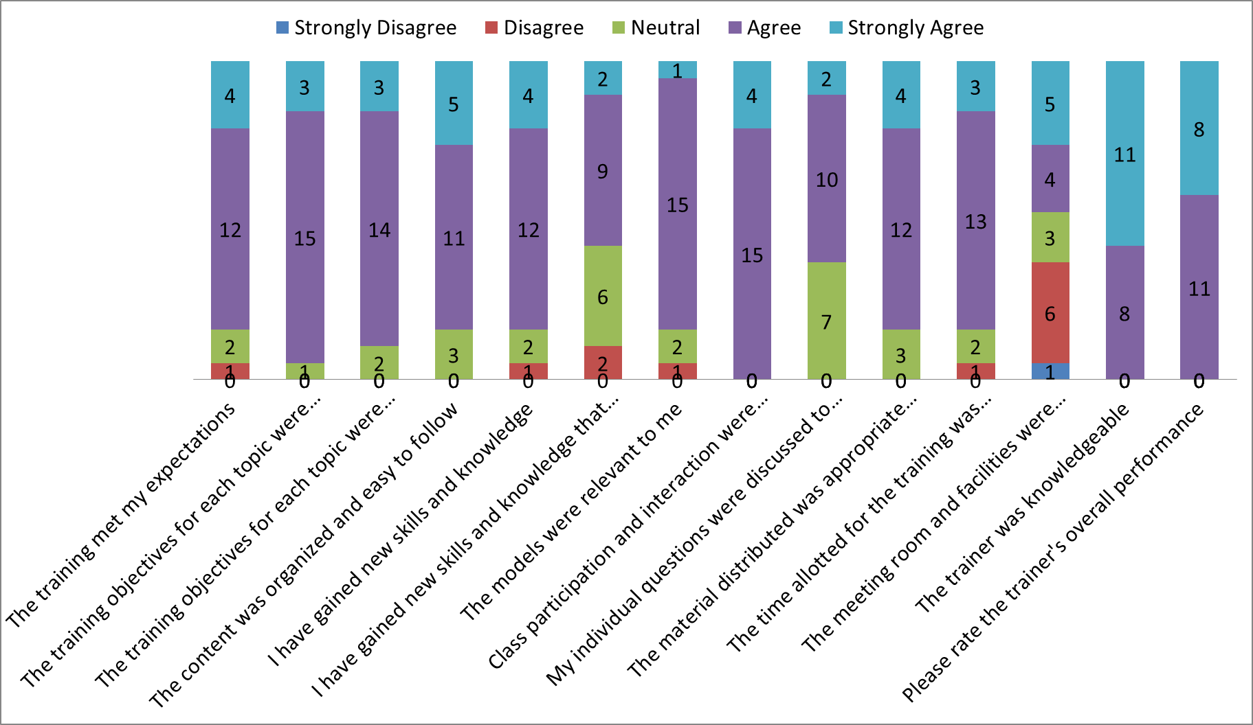

How did you learn about the training?
F1 Irritation by Lebanon Climate Act
F2 ALI / SLFI / MOE
F3 by email. I came to the first session at CIS-USJ and you sent an email to the one I provided that day
F4 Green Mind
F5 Direct mail Lebanon Climate Act
F6 From Green Mind- Lebanon Climate Act
F8 Invitation
F9 email invitation
F11 mail from CCIABML
F14 Through a friend
F15 by email
F16 Received an email
F17 Received an invitation
F18 From my manager
F19 UNDP

What did you like most about the training?
F1 Professionalism of the trainers + guidelines. Time management + organization
F3 the attitude and energy of the speakers. Plus the exercises. They covered all topics
F4 New initiative in Lebanon to ACT more responsible toward the environment. Networking
F5 The simple tools
F7 Calculation of CO2 emissions. Mitigating of CO2 emissions. Plan/ Action plan
F8 Wealth of information. New material
F10 The topic. The group enthusiasm
F11 The interaction with the group
F13 Interaction and participation
F15 It is very condensed and rich, and it gave us deep knowledge of climate change factors and how to identify appropriate actions to reduce carbon footprint
F17 Workshops
F18 I like the exercises implemented in groups that helped us understand and practice training objectives
F19 Understanding calculation of carbon footprint calculation

What are the three most important things (topics) you learned during this training?
F1 How to prioritize. Scopes (1, 2, 3). How to calculate our carbon footprint
F3 How to calculate our CO2 emissions. How the eco attitude and plan can help my business. What is sustainability.
F5 Carbon sheet (Excel). Stakeholders Prioritization
F8 CO2 footprint calculation. Decision optimization. Project management tools (module 5)
F11 Stakeholders identification. Climate change topics analysis. CO2 emissions calculation
F13 Impact created from companies affecting climate change. Prioritize harmful topics for climate change. Cooperation is important to make sustainable change
F14 Calculating carbon footprint
F15 Stakeholders importance. Climate change factors and how to identify them. Calculate carbon footprint
F18 Sustainability. Calculating gas emissions. Identification and prioritization of stakeholders
F19 Carbon footprint. Mitigation/ Adaptation. CSR

What aspects of the training would you improve?
F1 More team role/ More interactions between the trainees to “oblige” us to communicate and share ideas. More interactive exercises, maybe through games. Clear concrete examples of the exercises maybe you can send us a couple by email or upload it online. NO PLASTIC BOTTLES AND CUPS. Too much info all at once
F2 Better meeting place since the room had a noisy A/C and disturbed my hearing
F3 The time management but it didn’t bother me because the topics need days of discussion and I enjoyed it
F4 Allocate more time for each topic or reduce topics. Come up with initiatives where we push other companies/organizations/etc and not only attendants to reduce carbon footprint
F5 Reduce number of participants. Better location. Parking (!)
F8 Share list of participants for easy communication
F11 Discussion of more examples
F13 Explain different points by a graph or a sketch and less aspects more inclusion graphs
F14 Give an example per module before engaging trainees in the discussion to ensure clarity of the info delivered. Give time to practice
F15 The voice wasn’t very clear
F19 Location should be changed

Would you attend the upcoming session?
Definitely YES: 10
Probably YES: 6

Would you recommend the program to others?
Definitely YES: 11
Probably YES: 5

